15IT304J- Project Report

TRAVEL WEBSITE

# Team Members:

1. Shantanu Roy - RA1711003010835
2. Ujjwal Dadhich - RA1711003010905
3. Mihir Shailendra Lovekar - RA1711003010811

Introduction

A travel website is a website that is dedicated to travel. The site may be focused on travel reviews, hotel booking, trip fares, or a combination of all. Over 1.5 billion people book travel per year, 70% of which is done online. The website created by our group is a service provider whose main aim is to allow individuals to view and compare various hotels and allow them to book those hotels online and give great offers on tour packages, adventure sports, car rentals which are all included for better travelling experiences.

Travel websites have a lot of scope today as well as in future. This web programming project can be used by any hotels/restaurants/travel agencies to attract customers to visit various places and book hotels, car rentals, tour packages for it with the help of their websites. This project is easy, fast and accurate. It requires less disk space. Our website named ‘Travelix’ uses HTML, CSS, Javascript, PHP and MySQL for providing a great user experience to the customers as well as the hotels/restaurants/other service providers to connect with the customers for bookings. This website is a fully responsive website with mobile view as well.

# 1.1 Objective

The main objective of this system is to manage the details of customers, hotels, payment details, contact details, allow customers to book hotels, rent cars, book adventure sports and book tour packages, etc according to their own convenience. It manages all the information about hotel category, tour type, adventure sport, customer data, query information, other special services requested by the customer, etc. The project is totally built at consumer end and the consumer has complete access to the website. The purpose is to build an application program to reduce the stress from the hotel management chains in booking the travel tours, other as well as allow the customer to pick up and book hotels instantly in a few clicks.

# Needs of Online Travel Websites

Online Travel Websites(OTW)/Agencies gives you an instant access to large number of potential customers. Possible advantages of an online travel website/agency to sell the services include:

* It's a low cost way to list your to list your property and its rooms.
* Reductions in your online marketing spend. OTW will invest in marketing and advertising to attract potential international customers.
* A reduction in your website costs. OTWs are keen to provide a positive online experience for customers through good website design and functionality.
* Online travel sites are popular with customers who like to compare accommodation costs and the services offered by individual providers.
* Impartial reviews on online travel sites may give new customers the confidence to book.

However like any other thing in the world, it also has its own disadvantages:

* Online travel agents can charge commission on every sale. This can range between 10-20 percent of the gross cost.
* There may be restrictive terms and conditions imposed by OTWs such as guest cancellation and automatic room reselling policies.
* You may need to find a way of managing room availability across a range of OTAs, your own website, front desk and telephone sales. This can be time consuming and labour intensive. There are software options to help you manage this.
* Using OTAs does not reduce the need to have your own website with booking engine.
* You may still need to invest in a balanced multi-channel marketing strategy.

System Requirements

# HARDWARE REQUIREMENTS

1. Intel Pentium Processor or above.
2. 4GB RAM
3. 1 GB free disk space.

# SOFTWARE REQUIREMENTS

1. Windows Version7.0 or above.
2. Php Version 6.0 or above.
3. Xampp/ Wamp Server and MySQL
4. Text Editor. Eg- Notepad++, Atom, Sublime

System Architecture

# Methodology Development Model

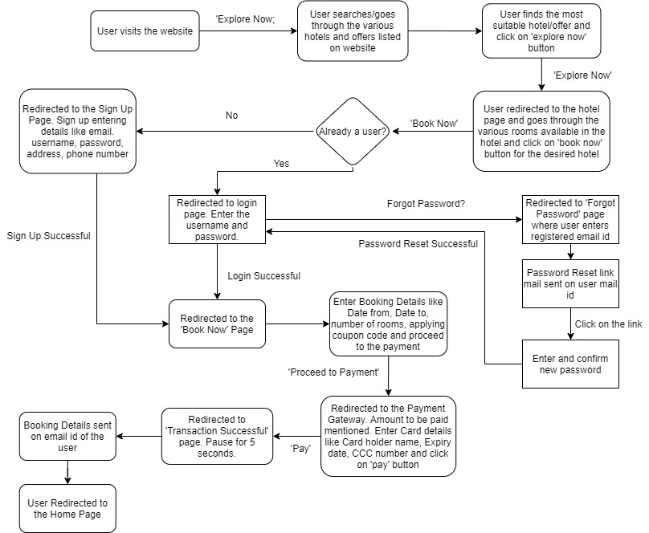

The sequential phases in Waterfall model are −

**Requirement Gathering and analysis** − All possible requirements of the system to be developed are captured in this phase and documented in a requirement specification document.

* + - **System Design** − The requirement specifications from first phase are studied in this phase and the system design is prepared. This system design helps in specifying hardware and system requirements and helps in defining the overall system architecture.
    - **Implementation** − With inputs from the system design, the system is first developed in small programs called units, which are integrated in the next phase. Each unit is developed and tested for its functionality, which is referred to as Unit Testing.
    - **Integration and Testing** − All the units developed in the implementation phase are integrated into a system after testing of each unit. Post integration the entire system is tested for any faults and failures.
    - **Deployment of system** − Once the functional and non-functional testing is done; the product is deployed in the customer environment or released into the market.
    - **Maintenance** − There are some issues which come up in the client environment. To fix those issues, patches are released. Also to enhance the product some better versions are released. Maintenance is done to deliver these changes in the customer environment

### Customer Features

1. View Hotel/Car rental/Trip/Adventure Sport Details
2. Select the desired hotel room/car/package/sport
3. Register/Create Account/Sign Up
4. Login/Sign In
5. Enter Booking Details
6. Pay Using Wallet
7. Receive booking details confirmation on mail id

Implementation

**CODE FOR CONNECTION WITH THE DATABASE**

|  |  |
| --- | --- |
| <?php |  |
|  |  |
|  | define('DB_SERVER', 'localhost'); |
|  | define('DB_USERNAME', 'root'); |
|  | define('DB_PASSWORD', ''); |
|  | define('DB_NAME', 'demo'); |
|  |  |
|  |  |
|  | $link = mysqli_connect(DB_SERVER, DB_USERNAME, DB_PASSWORD, DB_NAME); |
|  |  |
|  |  |
|  | if($link === false){ |
|  | die("ERROR: Could not connect. " . mysqli_connect_error()); |
|  | } |
|  | ?> |

**HOMEPAGE:**

**Some of the HTML code used:**

|  |  |
| --- | --- |
| **<!doctype html>** |  |
|  | **<html lang="en">** |
|  | **<head>** |
|  | **<meta charset="UTF-8">** |
|  | **<meta name="viewport"** |
|  | **content="width=device-width, user-scalable=no, initial-scale=1.0, maximum-scale=1.0, minimum-scale=1.0">** |
|  | **<meta http-equiv="X-UA-Compatible" content="ie=edge">** |
|  | **<title>Travelix</title>** |
|  | **<!--Font awesome CDN-->** |
|  | **<link rel="stylesheet" href="https://cdnjs.cloudflare.com/ajax/libs/font-awesome/5.13.0/css/all.min.css">** |
|  | **<link rel="stylesheet" href="styles.css">** |
|  | **</head>** |

|  |  |
| --- | --- |
| **<main class="main">** |  |
|  | **<div class="hero">** |
|  | **<div class="container">** |
|  | **<div class="main-heading">** |
|  | **<h1 class="title">Discover</h1>** |
|  | **<h2 class="subtitle">Luxurious Travelling</h2>** |
|  | **</div>** |
|  | **<a href="#explore" class="btn btn-gradient">Explore Now** |
|  | **<span class="dots"><i class="fas fa-ellipsis-h"></i></span>** |
|  | **</a>** |
|  | **</div>** |
|  | **</div>** |

**Use of header Tag:**

|  |  |
| --- | --- |
| **<header class="header">** |  |
|  | **<div class="container">** |
|  | **<nav class="nav">** |
|  | **<a href="index.html" class="logo">** |
|  | **<img src="./images/logo.png" alt="" class="logo-image">** |
|  | **</a>** |
|  | **<div class="hamburger-menu">** |
|  | **<i class="fas fa-bars"></i>** |
|  | **<i class="fas fa-times"></i>** |
|  | **</div>** |
|  | **<ul class="nav-list">** |
|  | **<li class="nav-item">** |
|  | **<a href="index.html" class="nav-link">Home</a>** |
|  | **</li>** |
|  | **<li class="nav-item">** |
|  | **<a href="#offer" class="nav-link">Offers</a>** |
|  | **</li>** |
|  | **<li class="nav-item">** |
|  | **<a href="#contact" class="nav-link">Contact</a>** |
|  | **</li>** |
|  | **<li class="nav-item">** |
|  | **<a href="login.html" class="nav-link">Login</a>** |
|  | **</li>** |
|  |  |
|  |  |
|  | **</ul>** |
|  | **</nav>** |
|  | **</div>** |
|  | **</header>** |

**Use of Footer Tag:**

|  |  |
| --- | --- |
| **<footer class="footer">** |  |
|  | **<div class="container">** |
|  | **<div class="footer-content">** |
|  | **<div class="footer-content-brand">** |
|  | **<a href="index.html" class="logo">** |
|  | **<img class="logo-image" src="./images/logo.png" alt="">** |
|  | **</a>** |
|  | **<div class="paragraph">** |
|  | **We are a travel agency company with more than 13 years of experience in the industry. We provide our customers** |
|  | **with the best experience and service and help them find their ideal hotel. We have a huge number of connections** |
|  | **with the hotel chains around the World. For any service related queries please contact us or email us. For more** |
|  | **updates please follow the links below.** |
|  | **</div>** |
|  | **</div>** |
|  | **<div class="social-media-wrap">** |
|  | **<h4 class="footer-heading">Follow Us</h4>** |
|  | **<div class="social-media">** |
|  | **<a href="#" class="sm-link"><i class="fab fa-twitter"></i></a>** |
|  | **<a href="#" class="sm-link"><i class="fab fa-facebook-square"></i></a>** |
|  | **<a href="#" class="sm-link"><i class="fab fa-instagram"></i></a>** |
|  | **<a href="#" class="sm-link"><i class="fab fa-linkedin"></i></a>** |
|  | **<a href="#" class="sm-link"><i class="fab fa-tripadvisor"></i></a>** |
|  | **</div>** |
|  | **</div>** |
|  | **</div>** |
|  | **</div>** |
|  | **</footer>** |

**Adding Video Element:**

|  |  |
| --- | --- |
| **<section class="hotels">** |  |
|  | **<div class="container">** |
|  | **<h5 class="section-head">** |
|  | **<span class="heading" id="explore">Watch Our Video Tour</span>** |
|  | **</h5>** |
|  | **<center><iframe width="1020" height="540" src="https://www.youtube.com/embed/EUaiyRplko0" frameborder="0"></iframe></center>** |
|  | **</div>** |
|  | **</section>** |

**Some of the Javascript Used:**

|  |  |
| --- | --- |
| let header = document.querySelector('.header'); |  |
|  | let hamburgerMenu = document.querySelector('.hamburger-menu'); |
|  |  |
|  | hamburgerMenu.addEventListener('click', function(){ |
|  | header.classList.toggle('menu-open'); |
|  | }) |
|  |  |
|  | window.addEventListener('scroll', function(){ |
|  | let windowPosition = window.scrollY > 0; |
|  | header.classList.toggle('active', windowPosition); |
|  | }) |

**Some of the CSS Used:**

|  |  |
| --- | --- |
| **html {** |  |
|  | **background: url('./images/room_2.jpg') no-repeat center center fixed;** |
|  | **-webkit-background-size: cover;** |
|  | **-moz-background-size: cover;** |
|  | **-o-background-size: cover;** |
|  | **background-size: cover;** |
|  | **}** |
|  |  |
|  | **body {** |
|  | **padding: 0;** |
|  | **margin: 0;** |
|  | **background: url('');** |
|  | **background-position: center;** |
|  | **font-family: 'Franklin Gothic Medium', 'Arial Narrow', Arial, sans-serif;** |
|  | **}** |
|  |  |
|  | **.login {** |
|  | **width: 400px;** |
|  | **height: 1000px;** |
|  | **background: transparent;** |
|  | **background-color: #fcf7f7;** |
|  | **border-radius: 30px;** |
|  | **border-style: ridge;** |
|  | **color: #5a3636;** |
|  | **top: 80%;** |
|  | **left: 50%;** |
|  | **position: absolute;** |
|  | **transform: translate(-50%, -50%);** |
|  | **box-sizing: border-box;** |
|  | **padding: 70px 30px;** |
|  | **border: 10px solid #c5bbbb;** |
|  | **}** |
|  |  |
|  | **.avatar {** |
|  | **width: 80px;** |
|  | **height: 80px;** |
|  | **border-radius: -50%;** |
|  | **position: absolute;** |
|  | **top: -2%;** |
|  | **left: calc(50% -50px);** |
|  | **left: 38%;** |
|  | **}** |
|  |  |
|  | **h1 {** |
|  | **margin: auto;** |
|  | **padding: 0 0 20px;** |
|  | **text-align: center;** |
|  | **font-size: 22px;** |
|  | **}** |
|  |  |
|  | **.login p {** |
|  | **margin: 0;** |
|  | **padding: 0;** |
|  | **font-weight: bold;** |
|  | **}** |

Screenshots

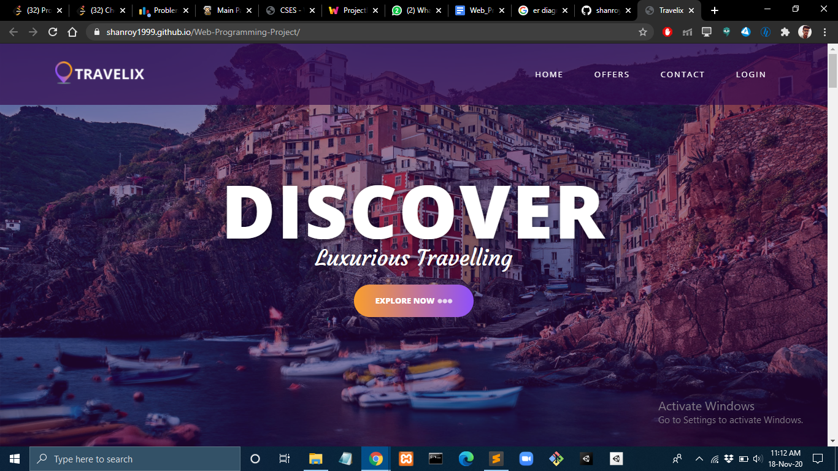

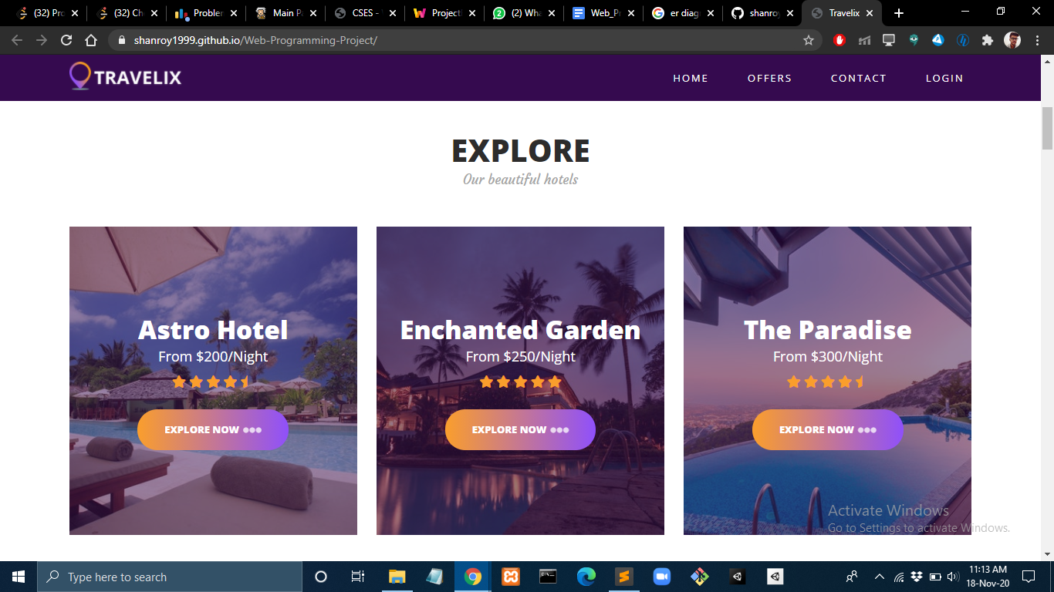

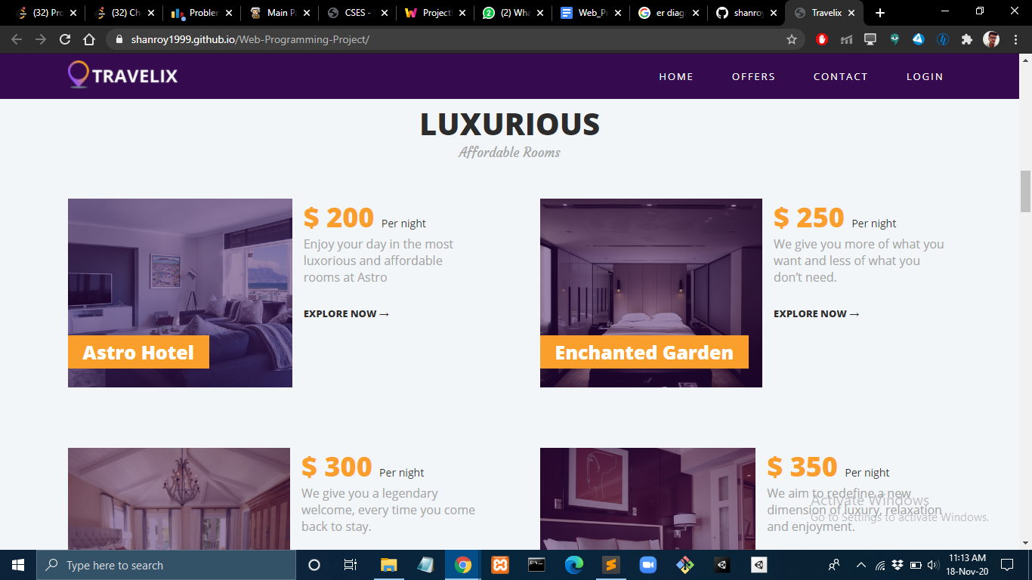

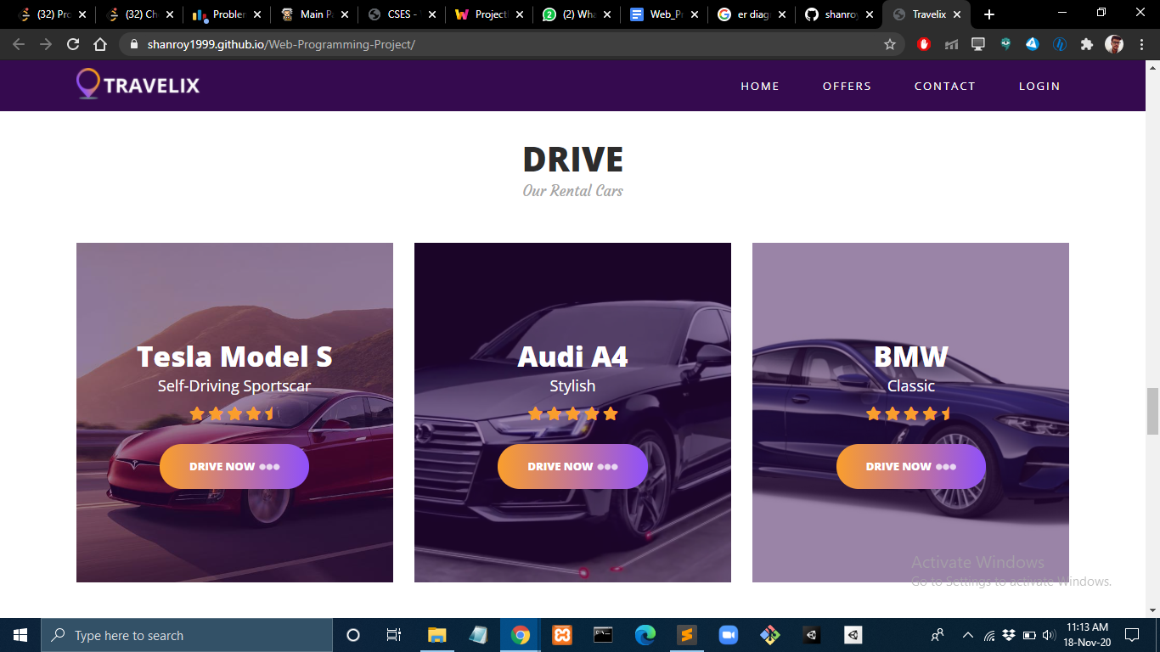

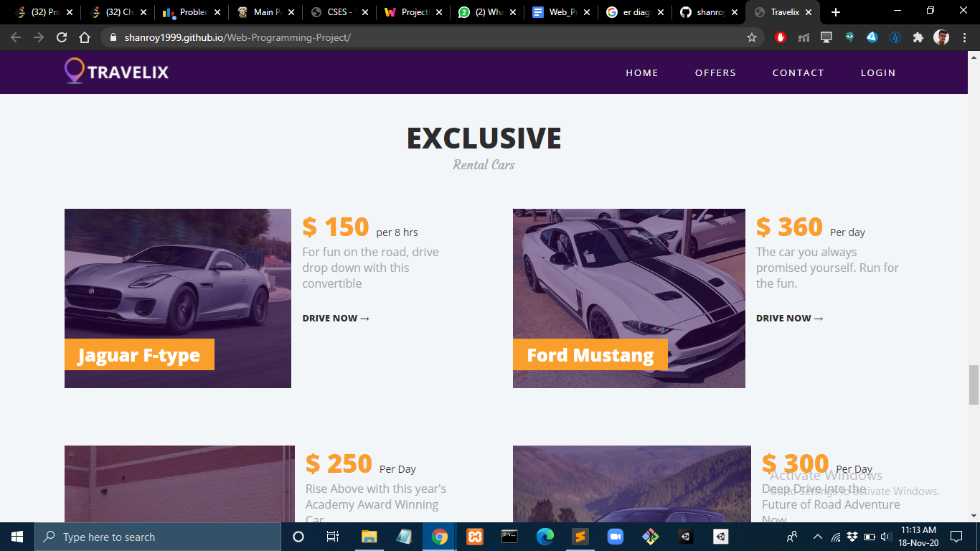

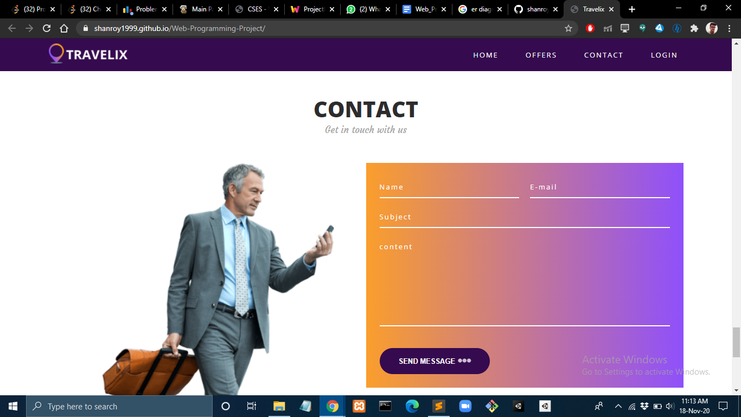

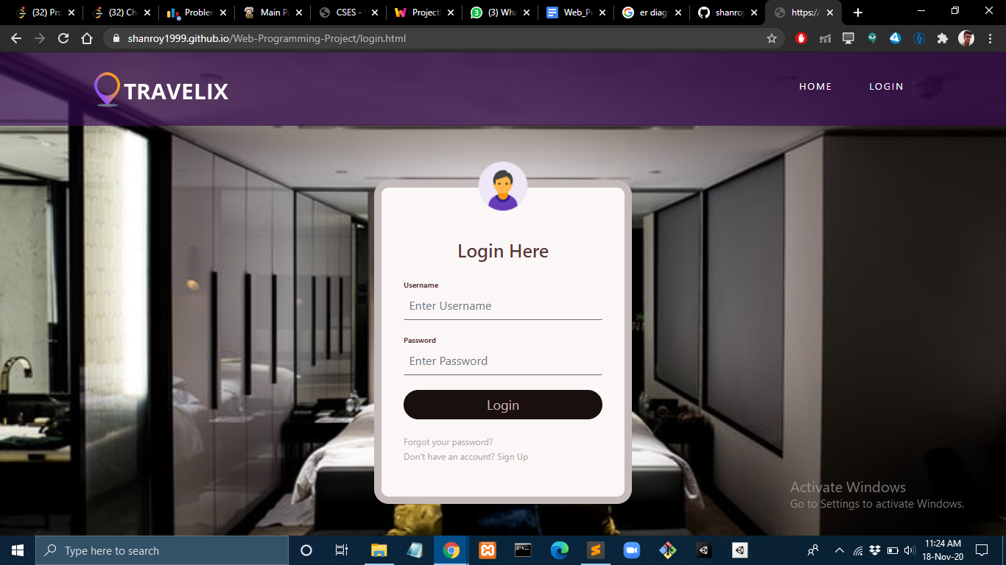

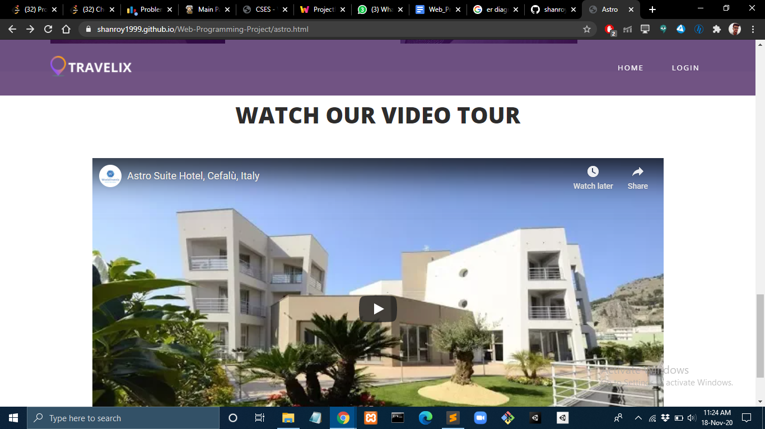

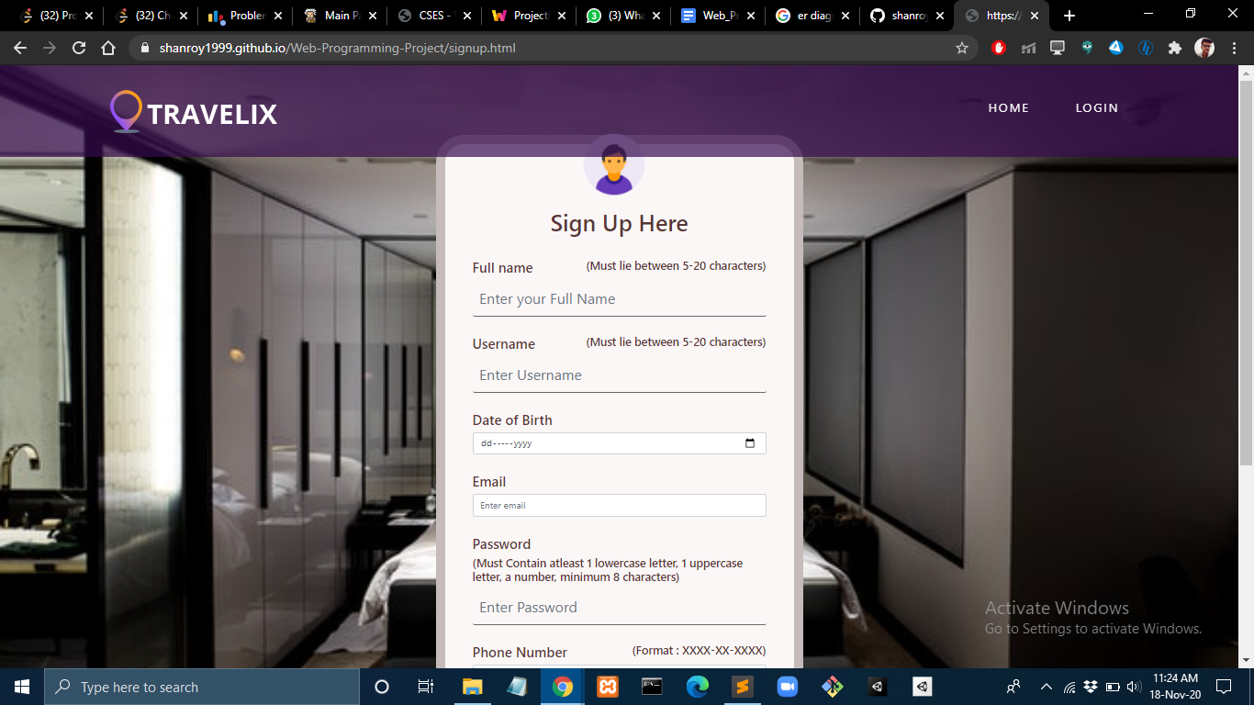

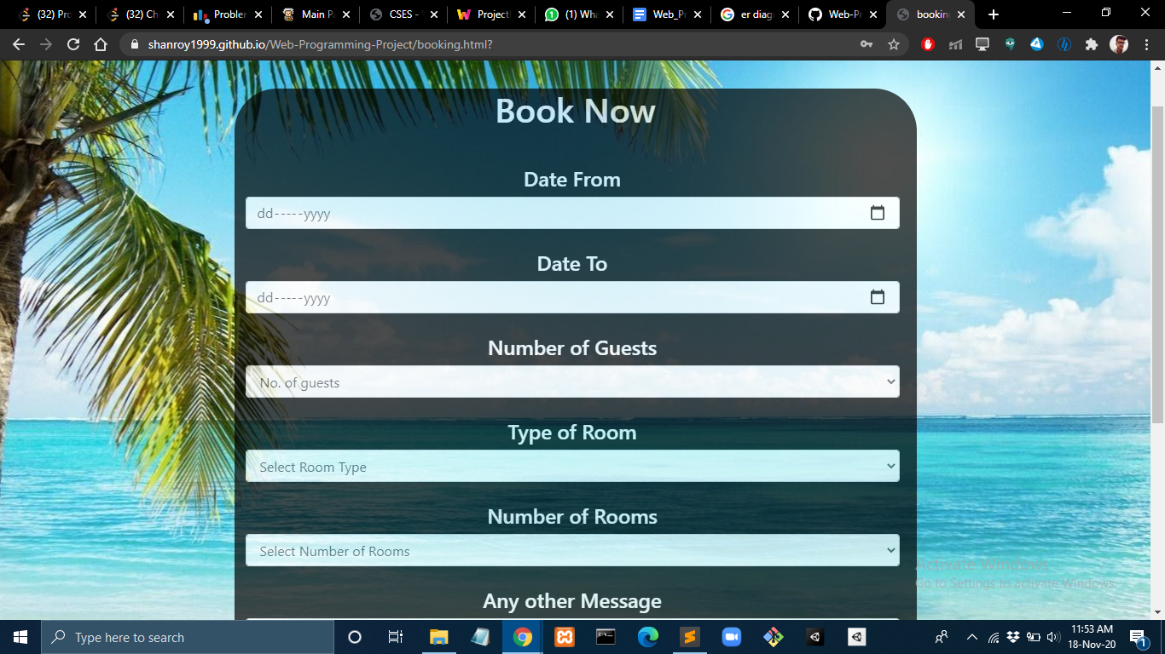

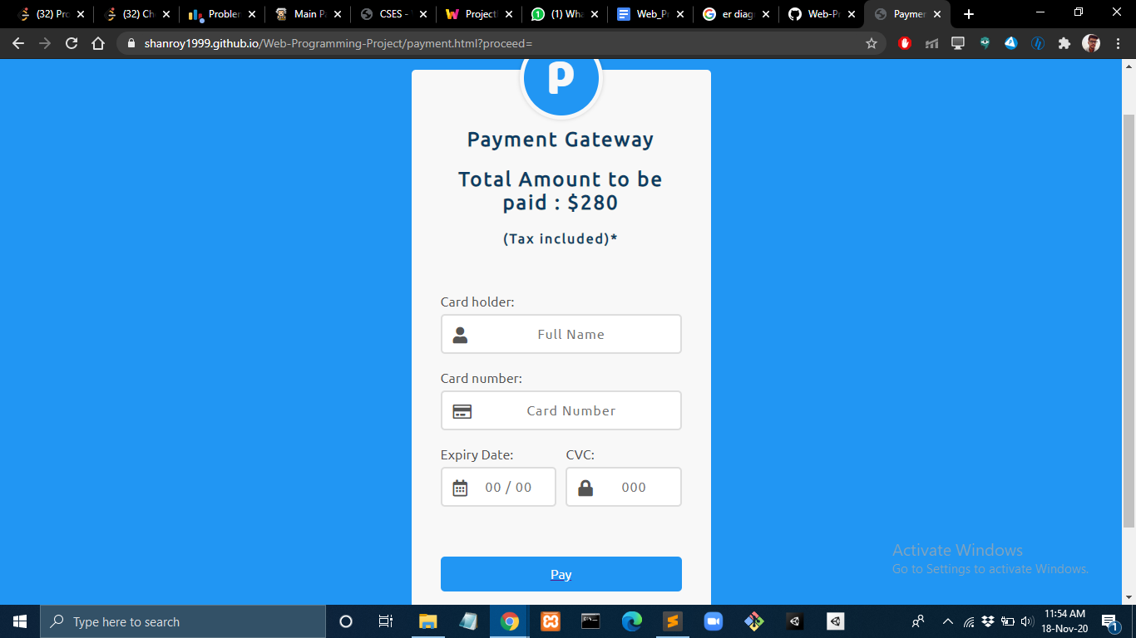

Conclusion And Future Work

* The project ‘Travel Website’ has been successfully implemented by using the various web development Tools.

.

* The future work will comprise of adding security features for the payment of the bookings to the project as well as a live chatbot for the assistance of the user in case of any queries.

References

* <https://www.w3schools.com/>
* <https://www.youtube.com/>
* “HTML and CSS Design” Book
* “Head first HTML” Book